Q.1 What is Android Programming?

Ans

1. Google acquired android incorporation on 17th August 2005.
2. Android was founded by Andy Rubin, Chris While, Rick Miner and Nick Sears
3. Android is an open-source and Linux based operating system
4. Features of Android
   1. UI
   2. Connectivity
   3. Storage
   4. Web Browser
   5. Multi-touch
   6. Messaging
   7. Multi-Language
   8. Wi-Fi
   9. Voice Based Support
5. R .file is used for connectivity between Java and Xml file.

Android versions are named based on a pattern, with early versions named after desserts in alphabetical order. Here's a brief overview of the major Android versions:

1. Early Android Versions

- Android 1.0 (2008): The first public release, with basic functionality like web browsing, camera, and email.

- Android 1.1 (2009): Minor updates to the initial release.

2. Dessert-Themed Versions

- Android 1.5 Cupcake (2009): Introduced the on-screen keyboard, third-party widgets, and video recording.

- Android 1.6 Donut (2009): Added support for different screen sizes, improved camera, and voice search.

- Android 2.0/2.1 Eclair (2009): Brought Google Maps navigation, live wallpapers, and improved browser.

- Android 2.2 Froyo (2010): Added support for push notifications, Flash, and performance improvements.

- Android 2.3 Gingerbread (2010): Introduced NFC (Near Field Communication) support, improved keyboard, and gaming.

- Android 3.0 Honeycomb (2011): A tablet-focused version with a redesigned interface.

- Android 4.0 Ice Cream Sandwich (2011): Unified the phone and tablet experience, added facial recognition unlock.

- Android 4.1-4.3 Jelly Bean (2012-2013): Brought smoother performance (Project Butter), Google Now, and expandable notifications.

- Android 4.4 KitKat (2013): Optimized for lower-end devices, introduced the "OK Google" voice command.

- Android 5.0-5.1 Lollipop (2014-2015): Introduced Material Design, notifications on the lock screen, and improved battery life (Project Volta).

- Android 6.0 Marshmallow (2015): Added Google Now on Tap, Doze mode for battery saving, and app permissions.

- Android 7.0-7.1 Nougat (2016-2017): Split-screen multitasking, notification direct reply, and improved Doze mode.

- Android 8.0-8.1 Oreo (2017-2018): Picture-in-picture mode, notification dots, and improved boot times.

- Android 9.0 Pie (2018): Gesture navigation, adaptive battery, and digital wellbeing features.

3. Numeric Versions

- Android 10 (2019): Dropped the dessert names. Introduced system-wide dark mode, smart replies, and enhanced privacy controls.

- Android 11 (2020): Focused on communication improvements with conversation notifications, built-in screen recording, and better permissions.

- Android 12 (2021): Introduced Material You, a new design language with personalized themes, privacy dashboard, and improved performance.

- Android 13 (2022): Enhanced customization, refined privacy features, and optimizations for large screens and foldable devices.

- Android 14 (2023): Improved battery efficiency, health and wellness features, satellite connectivity, and more refined user interface options.

Q.2 Architecture of android.

Ans

Android architecture is divided into 4 layers

1.Application Layer

2.Application Framework

3.Libraries and Android Runtime

4.Linux Kernel

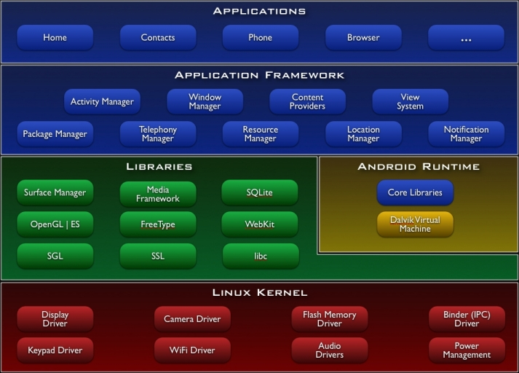

Android's architecture is indeed organized into four main layers, each playing a crucial role in the functioning of the Android operating system. Here's an overview of each layer:

1. Application Layer

- Description: This is the topmost layer where all Android applications reside. These include the apps pre-installed with the device (like contacts, phone, browser, etc.) as well as user-installed apps.

- Components: The applications at this layer are written in Java or Kotlin and interact with the Application Framework to perform tasks.

- Key Points:

- Users interact directly with the application layer.

- Apps are installed and run within this layer, providing functionalities to the user.

2. Application Framework

- Description: This layer provides the building blocks or APIs (Application Programming Interfaces) that developers use to create applications. The framework is designed to simplify app development by offering pre-coded modules.

- Components:

- Activity Manager: Manages the lifecycle of applications.

- Content Providers: Enable apps to share data with other apps.

- Resource Manager: Manages application resources like strings, layouts, and graphics.

- Notification Manager: Handles notifications for the user.

- View System: Provides UI components like buttons, lists, and text fields.

- Key Points:

- The framework provides services and common tasks to simplify app development.

- It ensures apps can interact with each other and access hardware efficiently.

3. Libraries and Android Runtime

- Libraries:

- Description: This part of the architecture includes a set of C/C++ libraries used by various components of the Android system. These libraries are critical for functions such as data storage, multimedia, graphics rendering, and web browsing.

- Key Libraries:

- Surface Manager: Manages display and compositing windows.

- Media Framework: Handles audio and video playback and recording.

- SQLite: A lightweight database engine used for data storage.

- OpenGL ES: A library for rendering 2D and 3D graphics.

- WebKit: A browser engine to display web content.

- Android Runtime (ART):

- Description: ART is the managed runtime used by applications, starting from Android 5.0 (Lollipop). It replaces the older Dalvik Virtual Machine.

- Key Features:

- Ahead-of-Time (AOT) Compilation: Improves app performance by compiling bytecode into machine code before execution.

- Garbage Collection: Manages memory by reclaiming unused memory automatically.

- Core Libraries: Provide essential functionalities like data structures, networking, and I/O operations.

4. Linux Kernel

- Description: The Linux Kernel is the foundation of the Android architecture, providing a layer of abstraction between the hardware and the rest of the software stack. It ensures that Android can efficiently manage resources and hardware components like the camera, memory, and network.

- Components:

- Drivers: Interfaces for hardware components like display, camera, Bluetooth, and Wi-Fi.

- Memory Management: Handles RAM and processes to ensure efficient use of device memory.

- Process Management: Manages tasks, threading, and process scheduling.

- Security: Implements security features such as SELinux (Security-Enhanced Linux) to protect against unauthorized access.

- Key Points:

- The Linux Kernel provides core system services and hardware abstraction.

- It manages device drivers, memory, processes, and network interfaces, ensuring Android can operate smoothly on a wide variety of devices.

**Summary**

**- Application Layer: Where user-installed apps run.**

**- Application Framework: Provides APIs and system services for app development.**

**- Libraries and Android Runtime: Supports low-level system functions and provides runtime for apps.**

**- Linux Kernel: The base layer that manages hardware and system resources.**

**Each layer builds upon the one beneath it, creating a cohesive system that allows developers to create powerful, flexible applications for Android devices.**

Q.3 Activity Lifecycle

Ans

The Android activity lifecycle is a crucial concept that dictates how an activity (a single screen with a user interface) transitions through various states during its lifetime. Understanding this lifecycle helps developers manage resources efficiently and provide a smooth user experience.

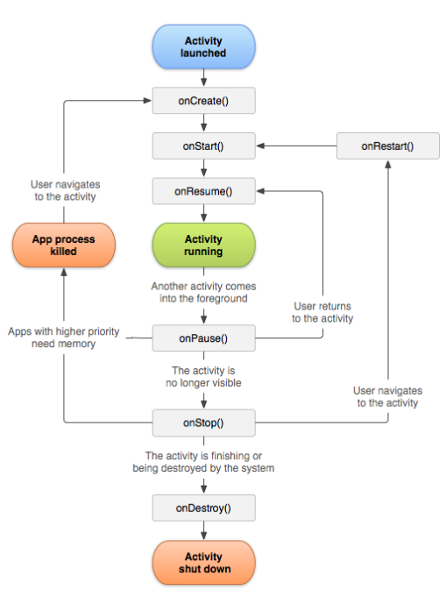

Callbacks of the Activity Lifecycle

1. `onCreate()`

- Triggered: When the activity is first created.

- Purpose: This is where you initialize your activity. You typically set up the UI, bind data to lists, and initialize components like buttons and text fields.

- Common Tasks:

- Inflate the layout with `setContentView()`.

- Initialize variables and UI components.

- Set up any needed data binding.

2. `onStart()`

- Triggered: When the activity becomes visible to the user.

- Purpose: The activity is about to become visible, but the user cannot interact with it yet.

- Common Tasks:

- Start animations.

- Prepare the UI to be visible.

- Initialize or refresh UI elements that need to be shown to the user.

3. `onResume()`

- Triggered: When the activity starts interacting with the user.

- Purpose: The activity is now in the foreground and the user can interact with it.

- Common Tasks:

- Start updating UI elements in real-time (e.g., start a camera preview).

- Resume any paused processes like audio playback.

- Start receiving user input.

4. `onPause()`

- Triggered: When the system is about to put the activity into the background.

- Purpose: The activity is still partially visible but the user is no longer interacting with it.

- Common Tasks:

- Pause ongoing tasks like animations or music playback.

- Save any unsaved data (e.g., draft text).

- Release resources that are not needed while the activity is paused.

5. `onStop()`

- Triggered: When the activity is no longer visible to the user.

- Purpose: The activity is completely hidden, and the system may stop it to free resources.

- Common Tasks:

- Release heavy resources (e.g., close database connections).

- Stop background threads.

- Save the state of the activity in case it needs to be recreated later.

6. `onRestart()`

- Triggered: When the activity is coming back to the foreground after being stopped.

- Purpose: The activity is being restarted after it was stopped, so it will become visible and interactable again.

- Common Tasks:

- Re-initialize resources that were released in `onStop()`.

- Re-initialize components that need to be refreshed before `onStart()` is called.

7. `onDestroy()`

- Triggered: When the activity is about to be destroyed.

- Purpose: The activity is being completely removed from memory, either because the user is finishing it or the system is temporarily destroying it to save space.

- Common Tasks:

- Clean up any remaining resources.

- Finalize any ongoing tasks.

- Save final state or data if necessary.

Q.4 IOS Architecture

Ans

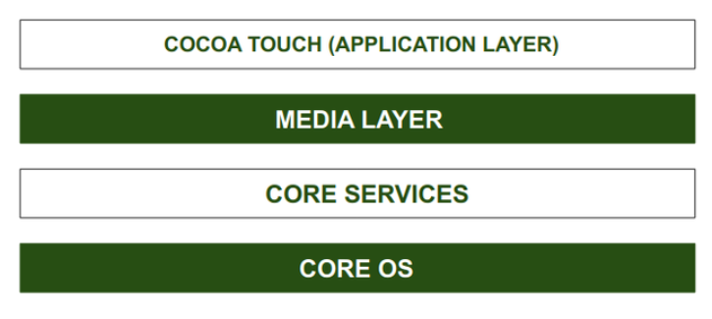

1. Cocoa Touch Layer

- Description: This is the topmost layer and is responsible for the user interface and user interaction. It provides the frameworks necessary to create and manage the user interface and handle user inputs.

- Key Frameworks:

- UIKit: The primary framework for building and managing the app's UI, including buttons, labels, views, and controls.

- Foundation: Provides essential data types, collections, and utilities, such as strings, arrays, and dates.

- Core Motion: Accesses motion-related data from the device’s hardware, such as the accelerometer and gyroscope.

- MapKit: Enables the integration of maps and location services.

2. Media Layer

- Description: This layer is responsible for providing audio, video, animation, and graphics services. It ensures that iOS apps can deliver a rich multimedia experience.

- Key Frameworks:

- Core Graphics (Quartz): Provides 2D drawing, transparency layers, and vector-based rendering.

- Core Animation: Manages animations and transitions for UI elements.

- AVFoundation: Handles audio and video playback, recording, and processing.

- Core Image: Provides powerful image processing and manipulation tools.

- Metal: A high-performance, low-level API for sophisticated graphics rendering and computation.

3. Core Services Layer

- Description: This layer contains fundamental system services that all apps need to use, including data management, networking, and device communication.

- Key Frameworks:

- Core Data: Manages object graphs and persistent storage, often used for managing complex data models.

- CloudKit: Provides cloud-based storage and syncing for app data.

- Core Location: Provides location services and geofencing.

- Networking: Frameworks like `NSURLSession` allow for robust networking capabilities.

- Address Book: Manages contacts and provides access to the user’s contacts database.

4. Core OS Layer

- Description: This is the lowest layer and provides the fundamental services upon which the other layers are built. It is responsible for memory management, file system handling, security, and networking.

- Key Components:

- Kernel: The heart of iOS, managing memory, file systems, processes, and network communication.

- Security Services: Provides encryption, authentication, and data protection features.

- Power Management: Efficiently manages battery life and system resources.

- Bluetooth: Manages Bluetooth communication.

- Libsystem: A collection of fundamental system libraries and utilities.

**Summary of iOS Architecture:**

**- Cocoa Touch Layer: Focuses on the user interface and interaction.**

**- Media Layer: Handles multimedia, graphics, and animations.**

**- Core Services Layer: Provides essential services like networking, data management, and location services.**

**- Core OS Layer: The foundation of the OS, managing hardware interactions, security, and system resources.**

Q.5 Intent, Adapters, Dialog, Menu

Ans

In Android development, intents, adapters, dialogs, and menus are fundamental concepts that help developers create interactive and functional applications. Here's an overview of each:

1. Intent

- Description: An intent is an object that allows you to start an activity or communicate with other components in Android, such as services, broadcast receivers, or other activities.

- Types of Intents:

- Explicit Intent: Specifies the target component (e.g., `MainActivity` to `DetailActivity`). It's used to launch a specific activity or service.

2. Adapter

- Description: An adapter acts as a bridge between a data source and the user interface (UI) components like `ListView`, `RecyclerView`, or `Spinner`. It provides a way to map data from sources like arrays, databases, or web APIs to views in the UI.

- Types of Adapters:

- ArrayAdapter: Used for binding an array or list of objects to a `ListView` or `Spinner`.

- CursorAdapter: Works with a database cursor to bind data to a UI component.

- RecyclerView.Adapter: Used with `RecyclerView` for handling large datasets efficiently by recycling views.

3. Dialog

- Description: A dialog is a small window that prompts the user to make a decision or enter additional information. It appears in the foreground and blocks interaction with the underlying activity until dismissed.

- Types of Dialogs:

- AlertDialog: The most common type, used for alerts and confirmations.

- ProgressDialog: Shows a progress indicator and is used during long-running operations.

- DatePickerDialog and TimePickerDialog: Allow users to select dates and times.

4. Menu

- Description: Menus in Android provide a way to offer actions and options to the user. They are typically used for navigation, settings, and other action-oriented tasks.

- Types of Menus:

- Options Menu: The primary menu, accessed via the app's toolbar or the overflow button. It usually contains the app's primary actions.

- Context Menu: A floating menu that appears when the user long-presses on a view. It provides context-specific actions.

- Popup Menu: A small menu that pops up from a view, offering a quick set of actions.

**Summary**

**- Intent: Facilitates communication between components, launching activities, and passing data.**

**- Adapter: Bridges data and UI, allowing views like `ListView` and `RecyclerView` to display data.**

**- Dialog: Presents temporary UI elements for user decisions, alerts, or input.**

**- Menu: Provides users with actionable items and navigation options within the app.**

**These components are essential for creating responsive, interactive, and user-friendly Android applications.**